**PIZZA SALES SQL QUERIES**

1. **KPI’S**
2. **Total Revenue:**

SELECT SUM(total_price)AS TOTAL_REVENUE FROM[dbo].[pizza_sales];

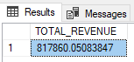

1. **Average Order Value**

SELECT SUM(total_price)/COUNT(DISTINCT order_id)AS AVG_ORDER_VALUE FROM[dbo].[pizza_sales];

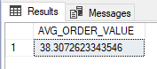

1. **Total Pizzas Sold**

SELECT SUM(quantity)AS TOTAL_PIZZA_SOLD FROM[dbo].[pizza_sales];

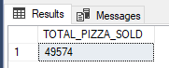

1. **Total Orders**

SELECT COUNT(DISTINCT order_id)AS TOTAL_ORDERS FROM[dbo].[pizza_sales];

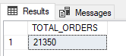

1. **Average Pizzas Per Order**

SELECT CAST(CAST(SUM(quantity)AS DECIMAL(10,2))/CAST(COUNT(DISTINCT order_id)AS DECIMAL(10,2)) AS DECIMAL(10,2)) FROM[dbo].[pizza_sales];

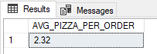

**B.DAILY TRENDS FOR TOTAL ORDERS**

SELECT DATENAME(DW,order_date)AS ORDER_DAY,COUNT(DISTINCT order_id)AS TOTAL_ORDERS

FROM[dbo].[pizza_sales]

GROUP BY DATENAME(DW,order_date);

OUTPUT:

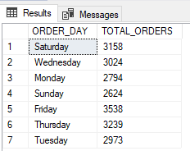

**C.HOURLY TRENDS FOR ORDERS**

SELECT DATEPART(HOUR,order_time)AS ORDER_HOURS,COUNT(DISTINCT order_id)AS TOTAL_ORDERS

FROM[dbo].[pizza_sales]

GROUP BY DATEPART(HOUR,order_time)

ORDER BY DATEPART(HOUR,order_time);

OUTPUT:

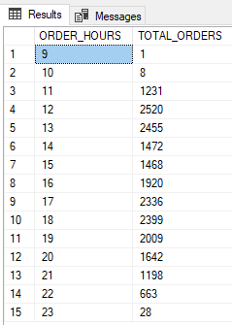

**D. %OF SALES BY PIZZA CATEGORY**

SELECT pizza_category, CAST(SUM(total_price) AS DECIMAL(10,2)) as TOTAL_REVENUE,

CAST(SUM(total_price) * 100 / (SELECT SUM(total_price) from pizza_sales) AS DECIMAL(10,2)) AS PCT

FROM pizza_sales

GROUP BY pizza_category;

OUTPUT:

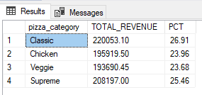

**E. %OF SALES BY PIZZA SIZE**

SELECT pizza_size, CAST(SUM(total_price) AS DECIMAL(10,2)) as TOTAL_REVENUE,

CAST(SUM(total_price) * 100 / (SELECT SUM(total_price) from pizza_sales) AS DECIMAL(10,2)) AS PCT

FROM pizza_sales

GROUP BY pizza_size

ORDER BY pizza_size;

OUTPUT:

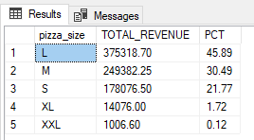

**F. TOTAL PIZZAS SOLD BY PIZZA CATEGORY**

SELECT pizza_category,SUM(quantity) AS TOTAL_QUANTITY_SOLD

FROM pizza_sales

WHERE MONTH(order_date)=2

GROUP BY pizza_category

ORDER BY TOTAL_QUANTITY_SOLD DESC;

OUTPUT:

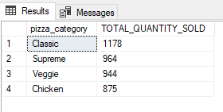

**G. TOP 5 BEST SELLERS BY TOTAL PIZZAS SOLD**

SELECT TOP 5 pizza_name,SUM(quantity) AS TOTAL_PIZZA_SOLD

FROM pizza_sales

GROUP BY pizza_name

ORDER BY TOTAL_PIZZA_SOLD DESC;

OUTPUT:

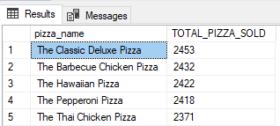

**H. BOTTOM 5 BEST SELLERS BY TOTAL PIZZAS SOLD**

SELECT TOP 5 pizza_name,SUM(quantity) AS TOTAL_PIZZA_SOLD

FROM pizza_sales

GROUP BY pizza_name

ORDER BY TOTAL_PIZZA_SOLD ASC;

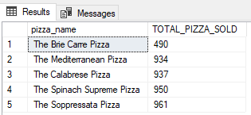

**NOTES:**

If you want to apply the Month, Quarter, Week filters to the above queries you can use WHERE clause. Follow some of below examples

SELECT DATENAME(DW, order_date) AS order_day, COUNT(DISTINCT order_id) AS total_orders

FROM pizza_sales

WHERE MONTH(order_date) = 1

GROUP BY DATENAME(DW, order_date)

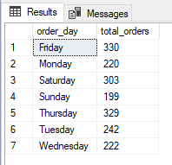

*\*Here MONTH(order_date) = 1 indicates that the output is for the month of January. MONTH(order_date) = 4 indicates output for Month of April.*

SELECT DATENAME(DW, order_date) AS order_day, COUNT(DISTINCT order_id) AS total_orders

FROM pizza_sales

WHERE DATEPART(QUARTER, order_date) = 1

GROUP BY DATENAME(DW, order_date)

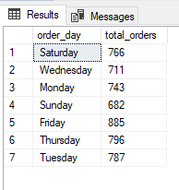

*\*Here DATEPART(QUARTER, order_date) = 1 indicates that the output is for the Quarter 1. MONTH(order_date) = 3 indicates output for Quarter 3.*